Lab Cycle 2:

Develop an app to display a progress Bar and show a message with alert dialog.

Step1 : Create a new Project and Wait for the Gradle build.
Step2 : Add the Progress Bar and Button from the Palette
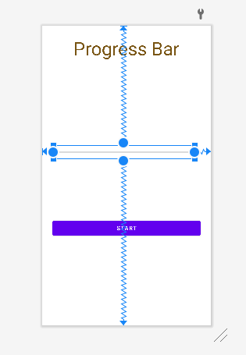
XML Code of Activity_main.xml
<Button
android:id="@+id/button"
android:layout_width="match_parent"
android:layout_margin="25dp"
android:layout_height="wrap_content"
android:text="Start"
app:layout_constraintBottom_toBottomOf="parent"
app:layout_constraintEnd_toEndOf="parent"
app:layout_constraintHorizontal_bias="0.498"
app:layout_constraintStart_toStartOf="parent"
app:layout_constraintTop_toTopOf="parent"
app:layout_constraintVertical_bias="0.702" />
<ProgressBar
android:id="@+id/progressBar2"
style="?android:attr/progressBarStyleHorizontal"
android:layout_width="345dp"
android:layout_height="32dp"
app:layout_constraintBottom_toBottomOf="parent"
app:layout_constraintEnd_toEndOf="parent"
app:layout_constraintHorizontal_bias="0.392"
app:layout_constraintStart_toStartOf="parent"
app:layout_constraintTop_toTopOf="parent"
app:layout_constraintVertical_bias="0.418" />
<TextView
android:id="@+id/textView"
android:layout_width="wrap_content"
android:layout_height="wrap_content"
android:text="Progress Bar"
android:textSize="45dp"
android:textAlignment="center"
android:textColor="#785412"
app:layout_constraintBottom_toTopOf="@+id/progressBar2"
app:layout_constraintEnd_toEndOf="parent"
app:layout_constraintHorizontal_bias="0.498"
app:layout_constraintStart_toStartOf="parent"
app:layout_constraintTop_toTopOf="parent"
app:layout_constraintVertical_bias="0.106" />

Java Code for MainActivity
//Variables declration

public Button button;
ProgressBar Progress;
CountDownTimer t;
float total;
@Override
protected void onCreate(Bundle savedInstanceState) {
super.onCreate(savedInstanceState);
setContentView(R.layout.activity_main);

// Program starts

button=findViewById(R.id.button);
Progress=findViewById(R.id.progressBar2);
Progress.setVisibility(View.INVISIBLE);
Progress.setMax(100);
button.setOnClickListener(new View.OnClickListener() {
@Override
public void onClick(View view) {
Progress.setVisibility(View.VISIBLE);
long min= 10*1000;//second * milisecond;
new CountDownTimer(min,1000)
{
@Override
public void onTick(long l) {
long a = min-l;
total= ((float)a/(float)min)*100;
Log.e("Total", String.valueOf( (a/min)));
Progress.setProgress((int) total);
}
@Override
public void onFinish() {
AlertDialog.Builder d = new AlertDialog.Builder(MainActivity.this);
d.setTitle(" Completed ").setMessage(" Loding as Been Completed").setPositiveButton("Yes", new DialogInterface.OnClickListener() {
@Override
public void onClick(DialogInterface dialogInterface, int i) {
Toast.makeText(MainActivity.this,"DOne",Toast.LENGTH_LONG).show();
}
});
AlertDialog dialog = d.create();
dialog.show();
}
}.start();
//
}
});
}

Output

